**Lab 5: Display devices, 7-segment display**

* Table with segments values for display 0 to 9 on a common anode 7-segment display

**Digit A B C D E F G DP**

**0** 0 0 0 0 0 0 1 1

**1** 100 1 1 1 1 1

**2** 0 0 1 0 0 1 0 1

**3** 0 0 0 0 1 1 0 1

**4** 1 0 0 1 1 0 0 1

**5** 0 1 0 0 1 0 0 1

**6** 0 1 0 0 0 0 0 1

**7** 0 0 0 1 1 1 1 1

**8** 0 0 0 0 0 0 0 1

**9** 0 0 0 0 1 0 0 1

* In your words, describe the difference between Common Cathode and Common Anode 7-segment display.

The main difference is where the segments are connected. In Common Cathode all of the LEDS are connected by its cathodes to one pin, while in Common Anode, they are connected by their anodes to just one pin. That means, that in Common Cathode, the LEDS will be active with a LOW and in Common Anode, they will be active at HIGH.

* Listing of library source file segment.c

/***********************************************************************

*

* Seven-segment display library for AVR-GCC.

* ATmega328P (Arduino Uno), 16 MHz, AVR 8-bit Toolchain 3.6.2

*

* Copyright (c) 2019-2020 Tomas Fryza

* Dept. of Radio Electronics, Brno University of Technology, Czechia

* This work is licensed under the terms of the MIT license.

*

**********************************************************************/

/* Includes ----------------------------------------------------------*/

#define *F_CPU* 16000000

#include <util/delay.h>

#include "gpio.h"

#include "segment.h"

/* Variables ---------------------------------------------------------*/

// Active-low digit 0 to 9

*uint8_t* segment_value[] = {

// abcdefgDP

0b00000011, // Digit 0

0b10011111, // Digit 1

0b00100101, // Digit 2

0b00001101, // Digit 3

0b10011001, // Digit 4

0b01001001, // Digit 5

0b01000001, // Digit 6

0b00011111, // Digit 7

0b00000001, // Digit 8

0b00001001 // Digit 9

};

// Active-high position 0 to 3

*uint8_t* segment_position[] = {

// p3p2p1p0....

0b00010000, // Position 0

0b00100000, // Position 1

0b01000000, // Position 2

0b10000000

};

/* Function definitions ----------------------------------------------*/

void SEG_init(void)

{

/* Configuration of SSD signals */

GPIO_config_output(&DDRD, SEGMENT_LATCH);

GPIO_config_output(&DDRD, SEGMENT_CLK);

GPIO_config_output(&DDRB, SEGMENT_DATA);

}

/*--------------------------------------------------------------------*/

void SEG_update_shift_regs(*uint8_t* segments, *uint8_t* position)

{

*uint8_t* bit_number;

segments = segment_value[segments]; // 0, 1, ..., 9

position = segment_position[position]; // 0, 1, 2, 3

// Pull LATCH, CLK, and DATA low

GPIO_write_low(&PORTD, SEGMENT_LATCH); // LATCH

GPIO_write_low(&PORTD, SEGMENT_CLK); // CLK

GPIO_write_low(&PORTB, SEGMENT_DATA); // DATA

// Wait 1 us

*_delay_us*(1);

// Loop through the 1st byte (segments)

// a b c d e f g DP (active low values)

for (bit_number = 0; bit_number < 8; bit_number++)

{

// Output DATA value (bit 0 of "segments")

if((segments % 2) == 0) //LSB is 0

{

GPIO_write_low(&PORTB,SEGMENT_DATA);

}else{

GPIO_write_high(&PORTB,SEGMENT_DATA);

}

// Wait 1 us

*_delay_us*(1);

// Pull CLK high

GPIO_write_high(&PORTD, SEGMENT_CLK);

// Wait 1 us

*_delay_us*(1);

// Pull CLK low

GPIO_write_low(&PORTD, SEGMENT_CLK);

// Shift "segments"

segments = segments >> 1;

}

// Loop through the 2nd byte (position)

// p3 p2 p1 p0 . . . . (active high values)

for (bit_number = 0; bit_number < 8; bit_number++)

{

// Output DATA value (bit 0 of "position")

if((position % 2) == 0) //LSB is 0

GPIO_write_low(&PORTB,SEGMENT_DATA);

else

GPIO_write_high(&PORTB,SEGMENT_DATA);

// Wait 1 us

*_delay_us*(1);

// Pull CLK high

GPIO_write_high(&PORTD, SEGMENT_CLK);

// Wait 1 us

*_delay_us*(1);

// Pull CLK low

GPIO_write_low(&PORTD, SEGMENT_CLK);

// Shift "position"

position = position >> 1;

}

// Pull LATCH high

GPIO_write_high(&PORTD, SEGMENT_LATCH);

// Wait 1 us

*_delay_us*(1);

}

/*--------------------------------------------------------------------*/

/* SEG_clear */

/*--------------------------------------------------------------------*/

/* SEG_clk_2us */

* Listing of decimal counter application main.c (at least two-digit decimal counter, ie. from 00 to 59),

/***********************************************************************

*

* Decimal counter with 7-segment output.

* ATmega328P (Arduino Uno), 16 MHz, AVR 8-bit Toolchain 3.6.2

*

* Copyright (c) 2018-2020 Tomas Fryza

* Dept. of Radio Electronics, Brno University of Technology, Czechia

* This work is licensed under the terms of the MIT license.

*

**********************************************************************/

/* Includes ----------------------------------------------------------*/

#include <avr/io.h> // AVR device-specific IO definitions

#include <avr/interrupt.h> // Interrupts standard C library for AVR-GCC

#include "timer.h" // Timer library for AVR-GCC

#include "segment.h" // Seven-segment display library for AVR-GCC

*uint8_t* cnt0 = 0;

*uint8_t* cnt1 = 0;

*uint8_t* pos = 0;

/* Function definitions ----------------------------------------------*/

/**

* Main function where the program execution begins. Display decimal

* counter values on SSD (Seven-segment display) when 16-bit

* Timer/Counter1 overflows.

*/

int main(void)

{

// Configure SSD signals

SEG_init();

// Test of SSD: display number '3' at position 0

SEG_update_shift_regs(cnt0, 0);

/* Configure 16-bit Timer/Counter1

* Set prescaler and enable overflow interrupt */

TIM1_overflow_1s();

TIM1_overflow_interrupt_enable();

/* Configure 16-bit Timer/Counter1

* Set prescaler and enable overflow interrupt */

TIM0_overflow_4ms();

TIM0_overflow_interrupt_enable();

// Enables interrupts by setting the global interrupt mask

sei();

// Infinite loop

while (1)

{

/* Empty loop. All subsequent operations are performed exclusively

* inside interrupt service routines ISRs */

}

// Will never reach this

return 0;

}

/* Interrupt service routines ----------------------------------------*/

/**

* ISR starts when Timer/Counter1 overflows. Increment decimal counter

* value and display it on SSD.

*/

ISR(TIMER1_OVF_vect)

{

cnt0++;

if(cnt0 >= 10){

cnt0 = 0;

cnt1 ++;

}

if(cnt1 >= 9)

cnt1 = 0;

SEG_update_shift_regs(cnt0,0);

}

ISR(TIMER0_OVF_vect)

{

pos++;

if(pos >= 4)

pos = 0;

if(pos == 0){

SEG_update_shift_regs(cnt0,pos);

}else if(pos == 1){

SEG_update_shift_regs(cnt1,pos);

}else{

SEG_update_shift_regs(0,pos);

}

}

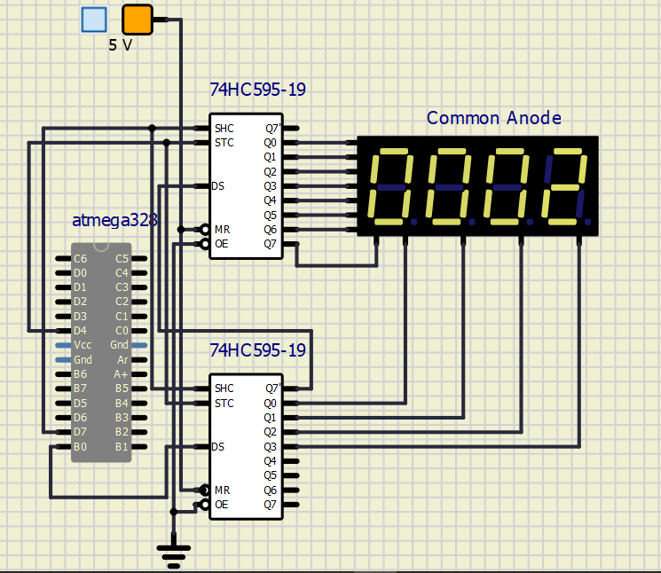

* Look-up table with snake definition

*uint8_t* segment_value[] = {

// abcdefgDP

0b01111111, // Digit a

0b10111111, // Digit b

0b11011111, // Digit c

0b11101111, // Digit d

0b11110111, // Digit e

0b11111011 // Digit f

};

* Listing of your snake cycling application main.c (at least one-digit snake).

/***********************************************************************

*

* Decimal counter with 7-segment output.

* ATmega328P (Arduino Uno), 16 MHz, AVR 8-bit Toolchain 3.6.2

*

* Copyright (c) 2018-2020 Tomas Fryza

* Dept. of Radio Electronics, Brno University of Technology, Czechia

* This work is licensed under the terms of the MIT license.

*

**********************************************************************/

/* Includes ----------------------------------------------------------*/

#include <avr/io.h> // AVR device-specific IO definitions

#include <avr/interrupt.h> // Interrupts standard C library for AVR-GCC

#include "timer.h" // Timer library for AVR-GCC

#include "segment.h" // Seven-segment display library for AVR-GCC

*uint8_t* cnt0 = 0;

*uint8_t* cnt1 = 0;

*uint8_t* pos = 0;

/* Function definitions ----------------------------------------------*/

/**

* Main function where the program execution begins. Display decimal

* counter values on SSD (Seven-segment display) when 16-bit

* Timer/Counter1 overflows.

*/

int main(void)

{

// Configure SSD signals

SEG_init();

// Test of SSD: display number '3' at position 0

SEG_update_shift_regs(cnt0, 0);

/* Configure 16-bit Timer/Counter1

* Set prescaler and enable overflow interrupt */

TIM1_overflow_1s();

TIM1_overflow_interrupt_enable();

/* Configure 16-bit Timer/Counter1

* Set prescaler and enable overflow interrupt */

TIM0_overflow_4ms();

TIM0_overflow_interrupt_enable();

// Enables interrupts by setting the global interrupt mask

sei();

// Infinite loop

while (1)

{

/* Empty loop. All subsequent operations are performed exclusively

* inside interrupt service routines ISRs */

}

// Will never reach this

return 0;

}

/* Interrupt service routines ----------------------------------------*/

/**

* ISR starts when Timer/Counter1 overflows. Increment decimal counter

* value and display it on SSD.

*/

ISR(TIMER1_OVF_vect)

{

SEG_clear();

cnt0++;

if(cnt0 >= 6){

cnt0 = 0;

}

SEG_update_shift_regs(cnt0,0);

}